**Screenshots of Key Visualizations and**

**Insights Summary**

**Key Visualizations**

**1. Mistake Rate Analysis**

* **Description**: Bar charts showcasing mistake rates for quizzes to identify areas where users are struggling.
* **Purpose**: Helps pinpoint specific quizzes or questions with high error rates, enabling targeted improvement.

**2. Score and Accuracy Trends**

* **Description**: Line plots illustrating how scores and accuracy have varied over time.
* **Purpose**: Tracks user progress, highlighting improvements or declines in performance.

**3. Topic-Wise Performance**

* **Description**: Bar charts visualizing the accuracy achieved across various topics.
* **Purpose**: Identifies strong and weak topics, assisting users in focusing on areas requiring more attention.

**4. Difficulty-Level Performance**

* **Description**: Bar charts comparing average scores for different difficulty levels.
* **Purpose**: Highlights how well users perform across varying difficulty levels, suggesting readiness for advanced quizzes or the need for foundational practice.

**Insights Summary**

**Strengths**

1. **High-Performing Topics**: Topics where accuracy exceeds 80%, demonstrating mastery.
2. **Low Mistake Rate**: Quizzes with error rates below 10%, indicating strong comprehension.
3. **Consistent Accuracy Trend**: A steady or improving accuracy trend over time.

**Areas for Improvement**

1. **Weak Topics**: Topics with accuracy below 50%, requiring focused revision.
2. **High Mistake Rate Quizzes**: Quizzes with mistake rates exceeding 20%, indicating a need for deeper understanding.
3. **Time Management**: Quizzes with low speed metrics, suggesting the need to enhance time management skills.

**Personalized Recommendations**

* Focus on revising weak topics and high mistake rate quizzes.
* Practice timed quizzes to improve speed.
* Explore advanced-level quizzes if average accuracy is consistently high.
* Sample Output –

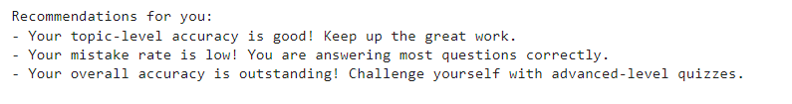

**Screenshots**

* Quiz Performance Breakdown

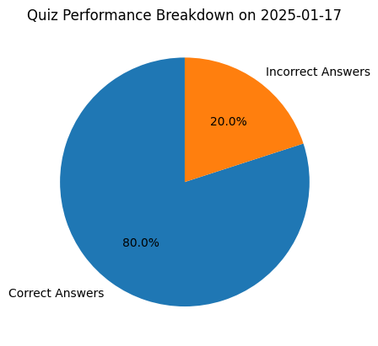

* Accuracy Trend Over Time for API Data – Trend Line Plot

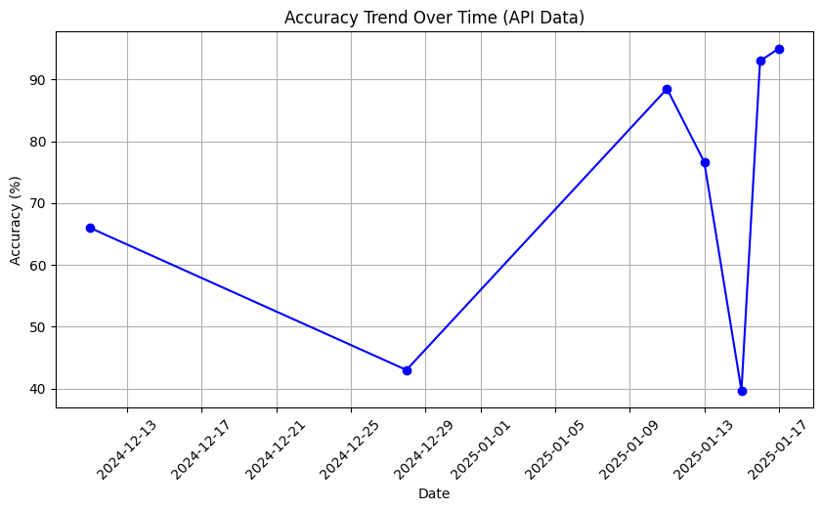

* Scores Trend Line Over Time

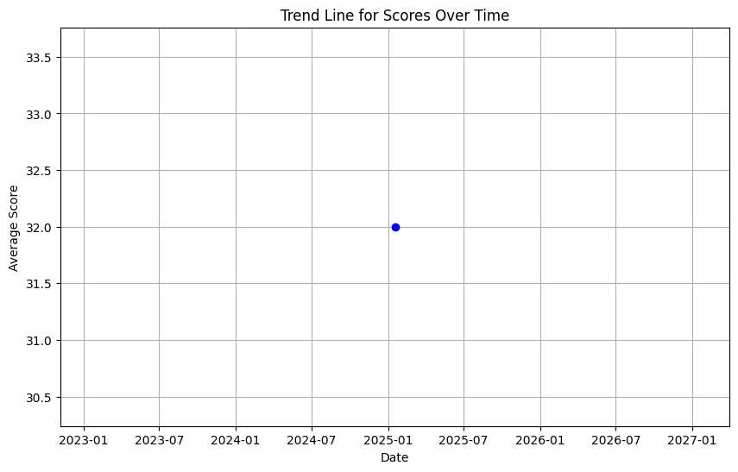

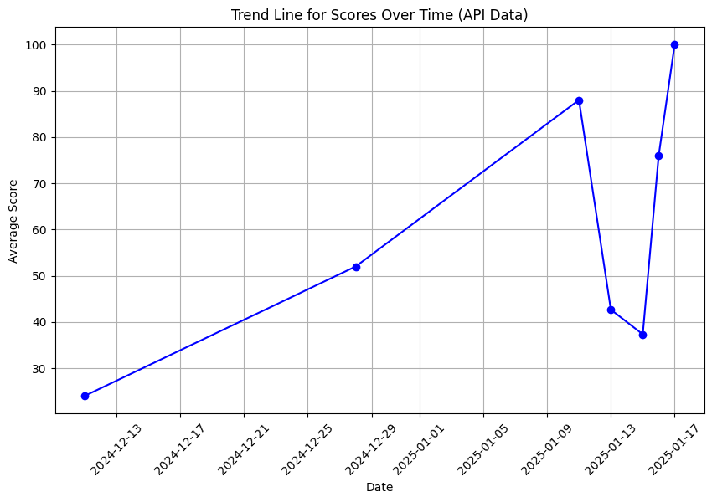

* Mistake Rate Analysis Bar Chart

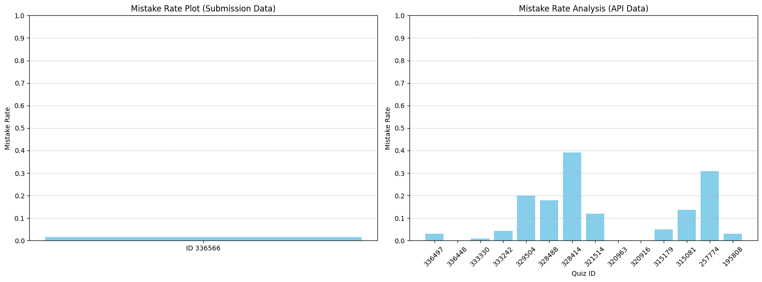

* Topic-Wise Performance Bar Chart

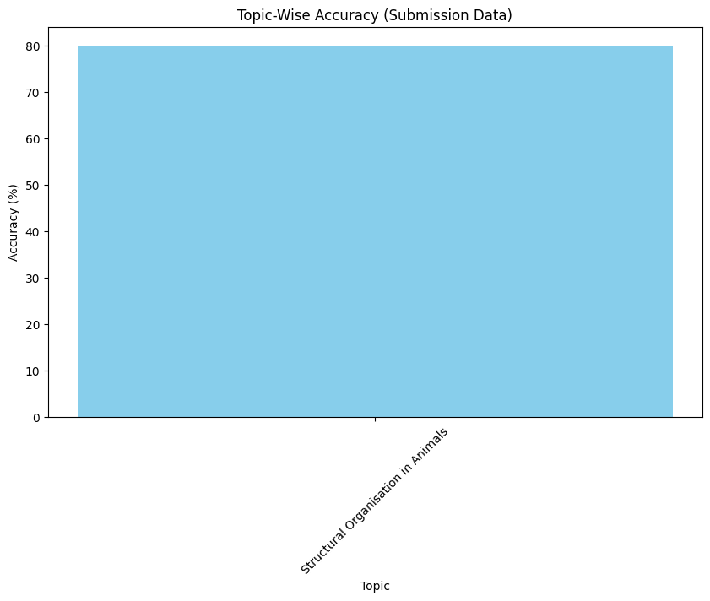

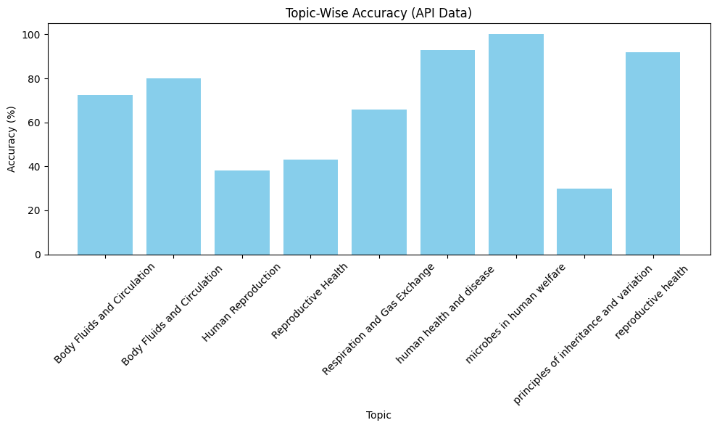

* Difficulty-Level Performance Comparisons –

This plot is blank as per data availability. The plot may be updated after updating JSON file.

